|  |
| --- |
| Institute for Information Industry |
| Golf Master API |
|  |

|  |
| --- |
| Copyright: Institute for Information Industry |

Table of Contents

Table of Contents 1

1. Introduction 2

1.1. 裝置業者與III串接流程 2

1.2. 現有版本串接注意事項 2

2. Golf Master API List 3

2.1. 擊球數據回饋 3

2.2. 擊球影像上傳(python) 7

2.3. 擊球分析結果(需要mqtt subscribe端) 9

2.4. 擊球影像分析結果(內部使用) 10

2.5. 傳輸給分析影像模組(python) 17

2.6. 回傳分析後影像(python) 18

2.7. 球桿選擇 19

2.8. 碼數表 21

2.9. 擊球數據 25

2.10. 擊球建議 27

2.11. 註冊E6(無使用) 28

2.12. 查詢影像 29

2.13. 登入系統(無使用) 31

1. Introduction
   1. 裝置業者與III串接流程

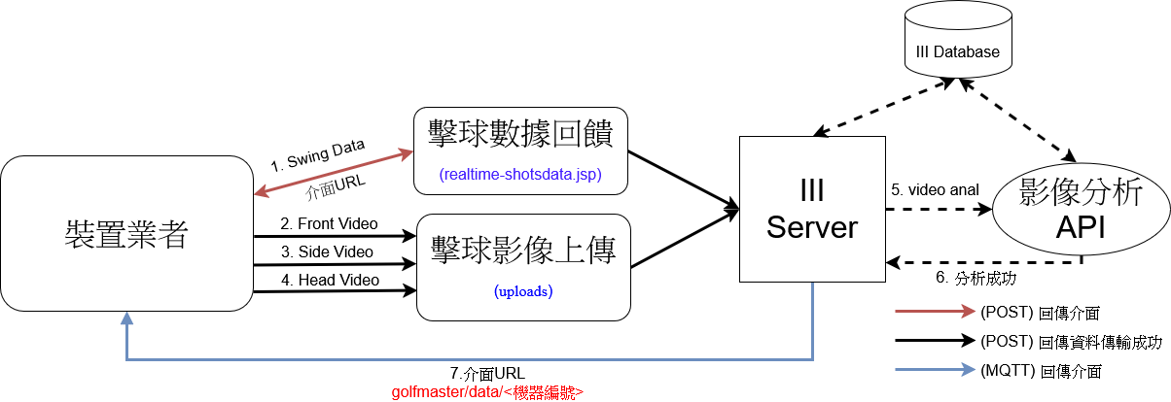

* 執行步驟：

1. 裝置上傳(POST)擊球數據(2.1)後，回傳範例網頁。
2. 裝置同時上傳(POST)擊球影像(2.2)：人物正面(front)、人物側面(side)、高爾夫球上方(head)等影像後，回傳資料是否接收成功。
3. III Server呼叫影像分析API(2.4)，分析擊球數據與擊球影像，回傳結果。
4. III Server發布(Publish)分析網頁(2.3)，至裝置業者MQTT server並顯示分析網頁。
   1. 現有版本串接注意事項
5. 數據上傳順序依序為擊球數據、人物正面影像、人物側面影像、球影像。
6. 裝置業者需要架設MQTT Server。
7. 上傳影像格式(**webm**)。
8. 影像分析API(2.4)為內部使用、其結果導入於分析網頁中。
9. 裝置業者需顯示回傳網頁結果(URL)
10. Mqtt port為1883，網頁port為80，影像上傳port為8080
11. Golf Master API List
    1. 擊球數據回饋

Request

|  |  |
| --- | --- |
| **Method** | **URL** |
| **POST** | http://61.216.149.161/GolfMaster/service/realtime-shotdata.jsp |

X-www-form-urlencoded Parameters

|  |  |  |  |  |
| --- | --- | --- | --- | --- |
| **Required** | **Type** | **Name** | **Values** | **Description** |
| **V** | **body** | idx | string | 模擬器標記數據之id |
| **V** | **body** | LID | string | 每個不同模擬器配合場域的odd |
| **V** | **body** | Player | string | 球員暱稱 |
| **V** | **body** | Date | date | 模擬器標記數據之時間字串(timestamp) |
| **V** | **body** | Token | string | 模擬器標記數據之Token(該次登入都相同) |
| **V** | **body** | BallSpeed | float | 高爾夫球在撞擊後立即的速度，球速是由球桿速度和衝擊力決定的。*技術定義：球速係指高爾夫球重心與桿面分離後的速度。  單位: mph |
| **V** | **body** | ClubAnglePath | float | 高爾夫擊球的預期曲率(旋轉軸)的關鍵因素。假設中心接觸，球應該朝向面角彎曲並遠離球桿路徑。單位: degree |
| **V** | **body** | ClubAngleFace | float | 高爾夫球手將此稱為具有“開放”或“封閉”桿面。*技術定義：在高爾夫球最大壓縮時，球桿面和高爾夫球接觸中心點的水平球桿面方向，單位: degree |
| **V** | **body** | TotalDistFt | float | 置球點到擊球後停止滾動的距離，單位: ft 呎 |
| **V** | **body** | CarryDistFt | float | 置球點到擊球落點的距離，單位: ft 呎 |
| **V** | **body** | LaunchAngle | float | 隨著球速的降低，最佳發射角度必須增加，  後旋也必須增加。單位: degree |
| **V** | **body** | SmashFactor | float | 球速除以球桿速度。 |
| **V** | **body** | BackSpin | float | 高爾夫球迴旋是高爾夫球的反向旋轉。 |
| **V** | **body** | SideSpin | float | 高爾夫球側旋是橫向發生的旋轉。 |
| **V** | **body** | ClubHeadSpeed | float | 從身體設置，到上桿頂點身體旋轉，讓手臂和身體將保持連接，保持在正確的揮桿平面上，並使用大肌肉來創造擊球過程。  (握壓/Swing/釋放/節奏)，單位: mph |
| **V** | **body** | LaunchDirection | float | 發射方向是球相對於目標線開始的初始方向。正發射方向表示球從目標右側開始，負發射方向。單位: degree |
| **V** | **body** | DistToPinFt | float | 擊球後與目標的距離，單位: ft 呎 |
| **V** | **body** | ClubType | string | 幾號球桿、材質 |
| 備註:回傳的網頁影像部分為範例影片，且沒有比對分析，LID使用1000或是以上的數字 | | | | |

範例輸入:

Key:shotData

Value:

{

"idx":"165359",

"LID":"sample",

"Player":"Player1",

"Date":"1734944039071",

"Token":"example-token",

"ShotData":{

"BallSpeed":150.5,

"ClubAnglePath":3.5,

"ClubAngleFace":1.2,

"TotalDistFt":300.0,

"CarryDistFt":280.0,

"LaunchAngle":12.0,

"SmashFactor":1.5,

"BackSpin":2500.0,

"SideSpin":200.0,

"ClubHeadSpeed":120.0,

"LaunchDirection":0.5,

"DistToPinFt":10.0,

"ClubType":"7Iron"

}

}

Response

|  |
| --- |
| **Response Content Type** |
| application/json |

|  |  |  |
| --- | --- | --- |
| **Name** | **Values** | **Description** |
| **Success** | boolean | 成功(true)與否(false) |
| **Result** | string | 成功顯示參數值，失敗顯示空字串 |

1. 回傳成功則範例如下：

{

“success": true,

"result": http://61.216.149.161/GolfMaster/service/expert-data-v7.jsp?expert=277048

}

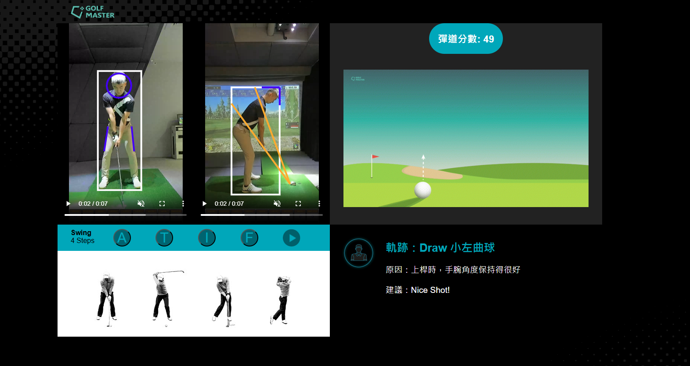

1. 失敗則回傳結果範例如下：

{

"success": false,

"result": "Error processing request"

}

* 1. 擊球影像上傳(python)

Request

|  |  |
| --- | --- |
| **Method** | **URL** |
| **POST** | http://61.216.149.161:8080/uploads |

form-data

|  |  |  |  |  |
| --- | --- | --- | --- | --- |
| **Required** | **Type** | **Name** | **Values** | **Description** |
| **V** | **body** | idx | int | 模擬器標記數據之id |
| **V** | **body** | LID | string | 每個不同模擬器配合場域的odd |
| **V** | **body** | Player | string | 使用者暱稱 |
| **V** | **body** | Date_str | string | 數據產生時間(年/月/日 時間) |
| **V** | **body** | Date | string | 模擬器標記數據之時間字串(timestamp) |
|  | **body** | shotVideo_front | file | 正面網路攝影機影像檔名 |
| **V** | **body** | shotVideo_side | file | 側面網路攝影機影像檔名 |
|  | **body** | headVideo | file | 桿頭高速攝影機影像檔名 |
| 備註:影像分別上傳，順序為front -> side -> head，擊球數據必須先有且必需有side影像 | | | | |

Response

|  |
| --- |
| **Response Content Type** |
| application/json |

|  |  |  |
| --- | --- | --- |
| **Name** | **Values** | **Description** |
| **msg** | string | 結果說明 |
| **status** | string | 成功(success)與否(fail) |

1. 回傳成功則範例如下：

{

status": success,

}

1. 失敗則回傳結果範例如下：

{

"msg": "ShotData 資料可能有問題，煩請再次確認。",

"status": fail,

}

或

{

"msg": "系統環境變數未設置完全。",

"status": fail,

}

或

{

"status": front fail

}

或

{

"status": side fail

}

或

{

"status": head fail

}

* 1. 擊球分析結果(需要mqtt subscribe端)

|  |  |
| --- | --- |
| **Method** | **Name** |
| Subscribe | golfmaster/data/<機器名稱(LID)> |
| 備註:mqtt port號為1883 | |

傳送

http://61.216.149.161/GolfMaster/service/expert-data-v7.jsp?expert=247025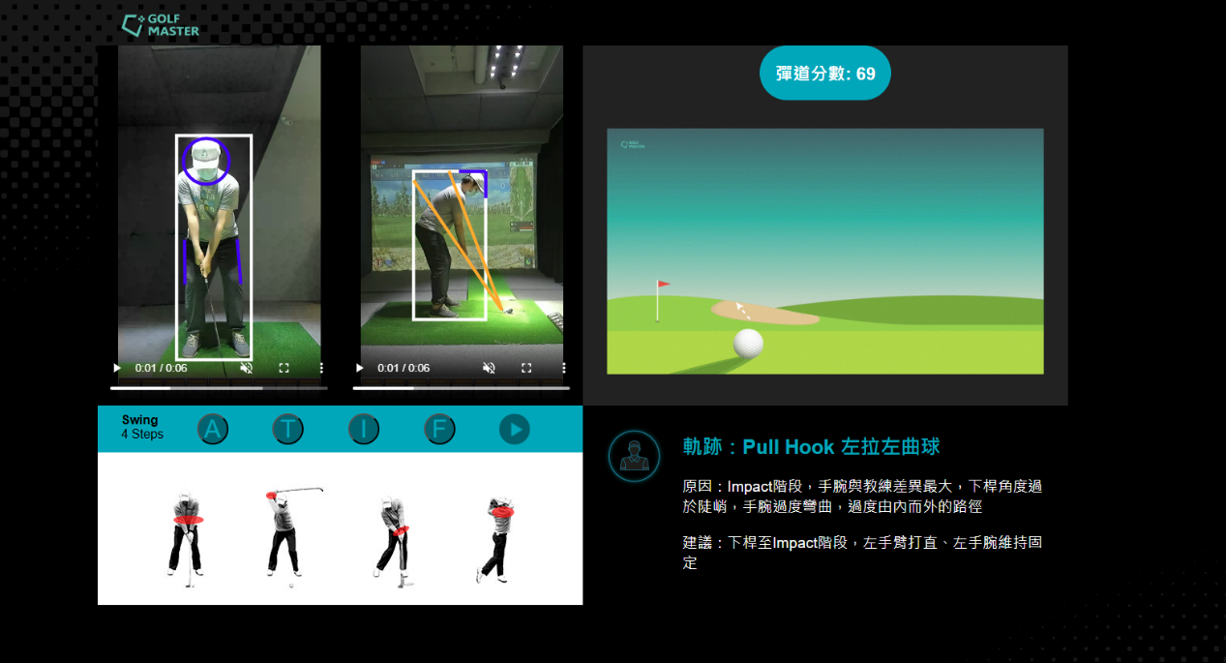

* 1. 擊球影像分析結果(內部使用)

|  |  |  |
| --- | --- | --- |
| **Name** | **Values** | **Description** |
| **success** | str | 成功(success)與否(fail) |
| **msg** | str | 輸出結果 |
| **(msg) task** | str | 原始輸入資訊 |
| **data_id** | str | 影片資料庫ID |
| filename | str | 影片名稱 |
| filepath | str | 影片路徑 |
| side | str | 相機拍攝方向(front, side) |
| player | str | 使用者名稱 |
| date | str | 國際時間 |
| timestamp | str | 時間戳點 |
| idx | str | 模擬器標記ID |
| shot_data_id | str | 擊球數據資料庫ID |
| club | str | 球桿種類 |
| task_name | str | 任務名稱(video_task) |
| (msg) swing_phase | str | 影像擊球階段時間戳點(frame) |
| success | bool | 分析成功(True)、分析失敗(False) |
| address | int | 設定之時間戳點 |
| toe_up | int | 起桿瞬間之時間戳點 |
| top | int | 上桿之時間戳點 |
| impact | int | 擊球之時間戳點 |
| finish | int | 完成之時間戳點 |
| tempo | float | 擊球節奏 |
| (msg) im_data | str | 擊球部位改善分析 |
| success | bool | 分析成功(True)、分析失敗(False) |
| name | str | 使用者模式(user) |
| dtype | int | 二維骨架分析(1) |
| phase_emb | str | 各階段擊球關節數據(12項)  ["l_shoulder angle",  "r_shoulder angle",  "l_elbow angle",  "r_elbow angle",  "l_hip angle",  "r_hip angle",  "l_knee angle",  "r_knee angle",  "shoulders slope",  "wrists slope",  "hips slope",  "ankles slope"  ] |
| (phase_emb) num_phase | int | 擊球階段總數 |
| (phase_emb) address | List  (float) | 設定之關節數據(12項) |
| (phase_emb) toe_up | List  (float) | 起桿瞬間之關節數據(12項) |
| (phase_emb) top | List  (float) | 上桿之關節數據(12項) |
| (phase_emb) impact | List  (float) | 擊球瞬間之關節數據(12項) |
| (phase_emb) finish | List  (float) | 完成之關節數據 |
| cmp | str | 教練與自身動作比對結果 |
| (cmp) coach | str | 教練數據 |
| (cmp) address | str | 設定動作改善分析(**改善分數越大越需改善**)  {"emb_score": 0.0, 整體相似比對分數  "shoulder": 0.0, 肩膀動作改善分數  "elbow": 0.0, 手肘動作改善分數  "wrist": 0.0, 手腕動作改善分數  "hip": 0.0, 髖關節動作改善分數  "knee": 0.0, 膝蓋動作改善分數  "ankle": 0.0, 腳踝動作改善分數  } |
| (cmp) toe_up | str | 起桿瞬間動作改善分析(**改善分數越大越需改善**) |
| (cmp) top | str | 上桿動作改善分析(**改善分數越大越需改善**) |
| (cmp) impact | str | 擊球瞬間動作改善分析(**改善分數越大越需改善**) |
| (cmp) finish | str | 完成動作改善分析(**改善分數越大越需改善**) |
| (msg) swing_plane | str | 影像輔助線標記結果 |
| (swing_plane) success | bool | 分析成功(True)、分析失敗(False) |
| (swing_plane) bbox | List  float | 人物標定框  [ltx, lty, rbx, rby] |
| (swing_plane) head | str | 頭部輔助線(**已正規化**)  {"pt": [0.0, 0.0], 參考點  "h_length": [0.0, 0.0], 垂直長度  "v_length": [0.0, 0.0], 水平長度  "h_pt": [0.0, 0.0], 水平參考點  "v_pt": [0.0, 0.0], 垂直參考點  }  正面: 參考點、垂直長度、水平長度  側面: 參考點、水平參考點、垂直參考點 |
| (swing_plane) club | str | 側面(side)，球桿擊球面輔助線(**已正規化**)  {"pt1": [0.0, 0.0],  "pt2": [0.0, 0.0],  } |
| (swing_plane) shoulder | str | 側面(side)，球桿至肩膀輔助線(**已正規化**)  {"pt1": [0.0, 0.0],  "pt2": [0.0, 0.0],  } |
| (swing_plane) left_leg | str | 正面(front)，左腳輔助線(**已正規化**)  {"pt1": [0.0, 0.0],  "pt2": [0.0, 0.0],  } |
| (swing_plane) right_leg | str | 正面(front)，右腳輔助線(**已正規化**)  {"pt1 ": [0.0, 0.0],  "pt2 ": [0.0, 0.0],  } |
| (msg) status | str | 完整分析成功(completed)  分析失敗(fail) |
| (msg) table_id | int | 未使用 |

{

"success": true,

"msg": {

"task":{

"data_id":143,

"filename":"Guest.1_shotVideo_side_161424_202404101614.mp4",

"filepath":"",

"side":"front",

"player":"Guest.1",

"date":"2024-04-10 16:14:06.939000",

"timestamp":"1712736846939",

"idx":"161406",

"shot_data_id":117340,

"club":"7Iron",

"task_name":"video_task"

},

"swing_phase":{

"success":true,

"address":93,

"toe_up":113,

"top":329,

"impact":705,

"finish":941,

"tempo":0.57

},

"im_data":{

"success":true,

"name":"user",

"dtype":1,

"phase_emb":{

"num_phases":5,

"address":[4.98,11.16,177.08,170.06,162.6,163.09,179.2,174.18,-179.98,-175.46,-177.32,176.47],

"toe_up":[9.91,15.43,179.61,170.51,163.38,164.74,177.87,173.46,178.58,-168.21,-177.33,176.58],

"top":[31.42,93.42,97.28,158.08,161.13,169.55,174.84,172.35,164.0,-31.23,179.64,176.58],

"impact":[10.84,1.61,172.31,154.61,158.56,166.55,179.96,176.15,-169.3,-159.11,-178.06,179.75],

"finish":[54.71,3.43,109.31,33.56,167.95,172.35,150.3,169.37,-12.95,-41.35,-11.4,175.69]

},

"cmp":{

"coach":{

"name":"coach_1",

"header":"Carol_Lee_shotVideo_front",

"club":"7Iron",

"phase":[342,362,503,571,703],

"tempo":2.07,

"emb_type":1.0,

"phase_emb":{

"num_phases":5,

"address":[3.52,6.55,178.24,178.11,164.78,169.24,173.21,176.86,-172.93,-152.02,-177.49,179.82],

"toe_up":[4.89,14.16,179.95,178.33,160.92,170.22,176.2,175.6,-176.51,-166.94,-177.19,179.35],

"top":[129.26,145.73,153.46,125.31,177.81,161.53,176.57,154.96,12.2,-12.03,176.03,176.87],

"impact":[7.54,10.35,173.07,175.91,162.27,177.48,143.17,175.15,-165.28,-157.93,-176.25,174.33],

"finish":[124.9,103.3,149.16,93.7,171.86,170.63,138.14,174.35,11.88,28.45,179.02,177.03]

}

},

"address":{

"emb_score":0.999,

"shoulder":-0.0,

"elbow":-0.0,

"wrist":0.001,

"hip":-0.0,

"knee":-0.0,

"ankle":-0.0

},

"toe_up":{

"emb_score":0.791,

"shoulder":0.209,

"elbow":-0.048,

"wrist":-0.021,

"hip":-0.066,

"knee":-0.048,

"ankle":-0.024

},

"top":{

"emb_score":0.919,

"shoulder":0.064,

"elbow":-0.003,

"wrist":0.001,

"hip":-0.031,

"knee":-0.02,

"ankle":-0.011

},

"impact":{

"emb_score":0.996,

"shoulder":-0.0,

"elbow":0.0,

"wrist":-0.0,

"hip":-0.001,

"knee":0.002,

"ankle":-0.0

},

"finish":{

"emb_score":0.855,

"shoulder":0.022,

"elbow":-0.01,

"wrist":0.012,

"hip":0.032,

"knee":-0.038,

"ankle":-0.025

}

}

},

"swing_plane":{

"success":true,

"bbox":[0.31347941645869504,0.1884737491607666,0.7055166173864293,0.8319971084594726],

"head":{

"pt":[0.5018518518518519,0.26666666666666666],

"h_length":0.11481481481481481,

"v_length":0.06458333333333334,

"h_pt":[0.0,0.0],

"v_pt":[0.0,0.0]

},

"club":{

"pt1":[0.0,0.0],

"pt2":[0.0,0.0]

},

"shoulder":{

"pt1":[0.0,0.0],

"pt2":[0.0,0.0]

},

"left_leg":{

"pt1":[0.6342592592592593,0.5088541666666667],

"pt2":[0.6509259259259259,0.6276041666666666]

},

"right_leg":{

"pt1":[0.37592592592592594,0.5052083333333334],

"pt2":[0.375,0.6291666666666667]

}

},

"status":"completed",

"table_id":-1

}

* 1. 傳輸給分析影像模組(python)

Request

|  |  |
| --- | --- |
| **Method** | **URL** |
| **POST** | http://61.216.149.161:8080/analyz_video |

X-www-form-urlencoded Parameters

|  |  |  |  |
| --- | --- | --- | --- |
| **Type** | **Name** | **Values** | **Description** |
| **body** | shotVideo_id | string | Video的id |
| **body** | analyzVideo_front | string | 分析後正面影像 |
| **body** | analyzVideo_side | string | 分析後側面影像 |
| 備註： | | | |

Response

|  |
| --- |
| **Response Content Type** |
| application/json |

|  |  |  |
| --- | --- | --- |
| **Name** | **Values** | **Description** |
| **status** | string | 狀態, success 或 fail |
| **msg** | string | 訊息 |

回傳成功則範例如下：

{

"status": "success",

"msg": "got analyze both video ID"

}

失敗則回傳結果範例如下：

{

"status": "fail",

"msg": "未提供正面或側面擊球影片"

}

* 1. 回傳分析後影像(python)

Request

|  |  |
| --- | --- |
| **Method** | **URL** |
| **POST** | http://61.216.149.161:8080/analyz_data |

X-www-form-urlencoded Parameters

|  |  |  |  |
| --- | --- | --- | --- |
| **Type** | **Name** | **Values** | **Description** |
| **body** | shotVideo_id | string | Video的id |
| **body** | id_analyzeVideo_front | string | 分析後正面影像id |
| **body** | id_analyzeVideo_side | string | 分析後側面影像id |
| 備註： | | | |

Response

|  |
| --- |
| **Response Content Type** |
| application/json |

|  |  |  |
| --- | --- | --- |
| **Name** | **Values** | **Description** |
| **status** | string | 狀態, success 或 fail |
| **msg** | string | 訊息 |

回傳成功則範例如下：

{

"status": "success",

"msg": "got analyze both video ID"

}

回傳部份成功則範例如下：

{

"status": "success",

"msg": "got analyze side video ID"

}

查詢失敗則回傳結果範例如下：

{

"status": "fail",

"msg": "未提供分析影片 ID"

}

* 1. 球桿選擇

Request

|  |  |
| --- | --- |
| **Method** | **URL** |
| **POST** | http://61.216.149.161/GolfMaster/service/coursestrategy.jsp |

X-www-form-urlencoded Parameters

|  |  |  |  |
| --- | --- | --- | --- |
| **Type** | **Name** | **Values** | **Description** |
| **body** | course | int | 球場代號 |
| **body** | holeNumber | string | 第幾球洞 |
| **body** | player | string | 球員暱稱 |
| **body** | tee | int | 開球位置(0 female 1 male) |
| **body** | clubs | string | 使用者持有球桿種類 |
| 備註： | | | |

Response

|  |
| --- |
| **Response Content Type** |
| application/json |

|  |  |  |
| --- | --- | --- |
| **Name** | **Values** | **Description** |
| **strategy** | string | 策略使用的球桿種類 |
| **code** | int | 成功(0)與否(-1) |
| **Standard** | boolean | 是否有個人數據 |
| **par** | string | 洞的標準杆數 |
| **courseName** | string | 球場名稱 |
| **holeNum** | string | 洞號 |

回傳成功則範例如下：

{

"code": 0,

"strategy": "1Wood-7Iron-Putter",

"Standard": true,

"par": "4",

"courseName": "Sample Course",

"holeNum": "1"

}

查詢失敗則回傳結果範例如下：

{

    "code": -1,

    "holeNumber": false

}

或

{

"code": -1,

"message": "Invalid parameters"

}

* 1. 碼數表

Request

|  |  |
| --- | --- |
| **Method** | **URL** |
| **POST** | http://61.216.149.161/GolfMaster/service  /yardage.jsp?player=Guest.1&type=month&start_date=2023-01-01&end_date=2023-08-02 |

X-www-form-urlencoded Parameters

|  |  |  |  |
| --- | --- | --- | --- |
| **Type** | **Name** | **Values** | **Description** |
| **body** | player | string | 球員暱稱 |
| **body** | start_date | string | 起始時間 |
| **body** | end_date | string | 結束時間 |
| 備註： | | | |

Response

|  |
| --- |
| **Response Content Type** |
| application/json |

|  |  |  |
| --- | --- | --- |
| **Name** | **Values** | **Description** |
| **success** | boolean | 成功(true)與否(false) |
| **ClubType** | string | 球桿種類 |
| **max** | double | 球桿最大距離 |
| **avg** | double | 球桿平均距離 |
| **min** | double | 球桿最小距離 |
| **result** | string | 球桿距離數據 |
| **code** | int | 結果代號 |
| **message** | string | 結果訊息 |

1. 回傳成功則範例如下：

{

    "result": [

        {

            "ClubType": "1Wood",

            "avg": 149.14,

            "min": 10,

            "max": 394.8

        },

        {

            "ClubType": "3Wood",

            "avg": 93.67,

            "min": 10,

            "max": 285.73

        },

        {

            "ClubType": "4Hybrid",

            "avg": 120.71,

            "min": 10.2,

            "max": 273.53

        },

        {

            "ClubType": "4Iron",

            "avg": 114.7,

            "min": 10.17,

            "max": 331.13

        },

        {

            "ClubType": "5Iron",

            "avg": 119.94,

            "min": 10.33,

            "max": 287.9

        },

        {

            "ClubType": "5Wood",

            "avg": 107.38,

            "min": 20.03,

            "max": 160.17

        },

        {

            "ClubType": "6Iron",

            "avg": 113.17,

            "min": 10.27,

            "max": 298.43

        },

        {

            "ClubType": "7Iron",

            "avg": 81.94,

            "min": 10.03,

            "max": 376.07

        },

        {

            "ClubType": "8Iron",

            "avg": 90.27,

            "min": 10.03,

            "max": 246.13

        },

        {

            "ClubType": "9Iron",

            "avg": 75.61,

            "min": 10,

            "max": 272.27

        },

        {

            "ClubType": "GapWedge",

            "avg": 49.74,

            "min": 10,

            "max": 195.8

        },

        {

            "ClubType": "PitchingWedge",

            "avg": 61.96,

            "min": 10.03,

            "max": 220.57

        },

        {

            "ClubType": "Putter",

            "avg": 62.04,

            "min": 57.9,

            "max": 64.7

        },

        {

            "ClubType": "SandWedge",

            "avg": 32.4,

            "min": 10,

            "max": 208.77

        }

    ],

    "code": 0,

    "success": true,

    "message": ""

}

1. 查詢失敗則回傳結果範例如下：

{

    "result": [],

    "code": -1,

    "success": false,

    "message": "參數不正確"

}

* 1. 擊球數據

Request

|  |  |
| --- | --- |
| **Method** | **URL** |
| **POST** | http://61.216.149.161/GolfMaster/service/shot-data.jsp |

X-www-form-urlencoded Parameters

|  |  |  |  |
| --- | --- | --- | --- |
| **Type** | **Name** | **Values** | **Description** |
| **body** | player | string | 球員暱稱 |
| **body** | start_date | string | 起始時間 |
| **body** | end_date | string | 結束時間 |
| 備註：如果沒有起始跟結束時間，則顯示最後十筆 yyyy-mm-dd 00:00:00 | | | |

Response

|  |
| --- |
| **Response Content Type** |
| application/json |

|  |  |  |
| --- | --- | --- |
| **Name** | **Values** | **Description** |
| **success** | boolean | 成功(true)與否(false) |
| **result** | string | 顯示擊球數據 |
| **error** | string | 錯誤編號 |
| **message** | string | 錯誤訊息 |

回傳成功則範例如下：

{

    "result": [

        {

            "BallSpeed": 14.843,

            "ClubAnglePath": 1.205,

            "Player": "Guest.1",

            "ClubAngleFace": 15,

            "expert_suggestion": "上桿時維持軸心，P2時桿身平行於雙腳之平行線，保持桿面角度，P2至P4胸椎充分旋轉，下桿時於P3重心往左，左半身帶領的同時，P5至P6右肩和右手肘維持外旋，左手腕在P5.5時屈曲，維持手腕角度過球，轉身至P10收桿。",

            "LID": "017",

            "TotalDistFt": 12.8,

            "CarryDistFt": 7.4,

            "LaunchAngle": 14.366,

            "SmashFactor": 0.54,

            "BackSpin": 804,

            "ClubHeadSpeed": 27.545,

            "Date": "2023-03-31 14:04:05",

            "LaunchDirection": 30.423,

            "DistToPinFt": 514,

            "SideSpin": -1430,

            "ClubType": "7Iron",

            "expert_cause": "上桿過度陡峭，下桿時突然過度由內往外打，或是上桿太內側且由內往外推所致。",

            "expert_p_system": "P2~3 上桿",

            "id": 11526,

            "expert_trajectory": "Push Slice 右拉右曲球"

        }

    ],

    "success": true

}

失敗則回傳結果範例如下：

{

    "success": false,

    "error": "ER0120",

    "message": "Missing required parameter."

}

* 1. 擊球建議

Request

|  |  |
| --- | --- |
| **Method** | **URL** |
| **POST** | http://61.216.149.161/GolfMaster/service/expert-data-v7.jsp? |

X-www-form-urlencoded Parameters

|  |  |  |  |
| --- | --- | --- | --- |
| **Type** | **Name** | **Values** | **Description** |
| **body** | expert | int | 建議對應擊球數據編號 |
| 備註： | | | |

Response

|  |
| --- |
| **Response Content Type** |
| application/json |

|  |  |  |
| --- | --- | --- |
| **Name** | **Values** | **Description** |
| **expert_trajectory** | string | 球路類型 |
| **expert_p_system** | string | Psystem階段問題 |
| **expert_suggestion** | string | 專家建議 |
| **expert_cause** | string | 問題原因 |
| **result** | boolean | 結果成功或失敗 |
| **video** | string | 影片名稱 |
| **img_name** | string | 圖片名稱 |

成功結果範例:

{

"expert_trajectory": "Pull Hook 左拉左曲球",

"expert_p_system": "P5~6 下杆",

"expert_suggestion": "下杆至Impact階段，左手臂打直、左手腕維持固定",

"expert_cause": "Impact階段，手腕與教練差異最大，下杆角度過於陡峭，手腕過度彎曲，過度由內而外的路徑",

"result": true,

"video": "P1_P10v5.mp4",

"img_name": "warning.png"

}

失敗結果範例：

{

"result": false,

"message": "Invalid expert ID"

}

* 1. 註冊E6(無使用)

Request

|  |  |
| --- | --- |
| **Method** | **URL** |
| **POST** | http://61.216.149.161/GolfMaster/service/golfmasterregister.jsp |

X-www-form-urlencoded Parameters

|  |  |  |  |
| --- | --- | --- | --- |
| **Type** | **Name** | **Values** | **Description** |
| **body** | account | String | 帳號 |
| **body** | password | String | 密碼 |
| **body** | nickname | String | 暱稱 |
| **body** | dexterity | int | 慣用手 (1: 右手, 2: 左手) |
| **body** | name | String | 姓名 |
| **body** | birth | String | 出生日期 (格式: YYYY-MM-DD) |
| **body** | gender | int | 性別 (1: 男, 2: 女) |
| **body** | tee | int | 球道類型 |
| **body** | phone | String | 電話號碼 |
| 備註： | | | |

Response

|  |
| --- |
| **Response Content Type** |
| application/json |

|  |  |  |
| --- | --- | --- |
| **Name** | **Values** | **Description** |
| **code** | int | 狀態碼，0表示成功，-1表示失敗 |
| **success** | boolean | 是否成功 |
| **message** | string | 訊息 |

成功結果範例:

{

"code": 0,

"success": true,

"message": "註冊完成"

}

失敗結果範例：

{

"code": -1,

"success": false,

"message": "資料有誤"

}

* 1. 查詢影像

Request

|  |  |
| --- | --- |
| **Method** | **URL** |
| **POST** | http://61.216.149.161/GolfMaster/service /shot-video.jsp |

X-www-form-urlencoded Parameters

|  |  |  |  |
| --- | --- | --- | --- |
| **Type** | **Name** | **Values** | **Description** |
| **body** | player | String | 暱稱 |
| **body** | video_id | String | 影片id |
| **body** | raw_shotVideo_front | String | 正面影像 |
| **body** | raw_shotVideo_side | String | 側面影像 |
| 備註： | | | |

Response

|  |
| --- |
| **Response Content Type** |
| application/json |

|  |  |  |
| --- | --- | --- |
| **Name** | **Values** | **Description** |
| **result** | Array | 影像分析結果 |
| **success** | boolean | 是否成功 |
| **message** | string | 訊息 |

成功結果範例:

{

"success": true,

"result": [

{

"id": 1,

"player": "Sample Player",

"video_id": "12345",

"analysis_result": "Sample Analysis Result"

}

]

}

失敗結果範例：

{

"success": false,

"message": "Invalid video ID"

}

* 1. 登入系統(無使用)

Request

|  |  |
| --- | --- |
| **Method** | **URL** |
| **POST** | http://61.216.149.161/GolfMaster/service /golfmasterlogin.jsp |

X-www-form-urlencoded Parameters

|  |  |  |  |
| --- | --- | --- | --- |
| **Type** | **Name** | **Values** | **Description** |
| **body** | account | String | 帳號 |
| **body** | password | String | 密碼 |
| 備註： | | | |

Response

|  |
| --- |
| **Response Content Type** |
| application/json |

|  |  |  |
| --- | --- | --- |
| **Name** | **Values** | **Description** |
| **code** | int | 狀態碼，0表示成功，-1表示失敗 |
| **success** | boolean | 是否成功 |
| **message** | string | 訊息 |

成功結果範例:

{

"code": 0,

"success": true,

"message": "登錄成功"

}

失敗結果範例：

{

"code": -1,

"success": false,

"message": "帳號密碼錯誤"

}